Project Design Phase
Problem – Solution Fit Template

Date | 14 Feb 2026
Team ID | LTVIP2026TMIDS74950
Project Name | LearnHub: Your Center for Skill Enhancement
Maximum Marks | 2 Marks

Problem – Solution Fit Template:
The Problem–Solution Fit means identifying a real problem faced by users and developing a solution that effectively addresses those problems. It ensures that the developed system aligns with user needs and improves their overall experience.
Purpose:
- Solve real-world challenges in digital education by providing a secure, structured, and user-friendly Learning Management System tailored to students, teachers, and administrators.
- Increase platform adoption by aligning the solution with existing user behaviors such as online learning, self-paced study, and digital course enrollment.
- Improve communication and engagement by delivering clear course structures, secure authentication, and transparent enrollment workflows.
- Enhance user trust and interaction by solving common problems such as insecure access, lack of progress tracking, and absence of certification proof.
- Understand the current limitations of online learning systems and continuously improve the platform to better serve the target audience.

Template:
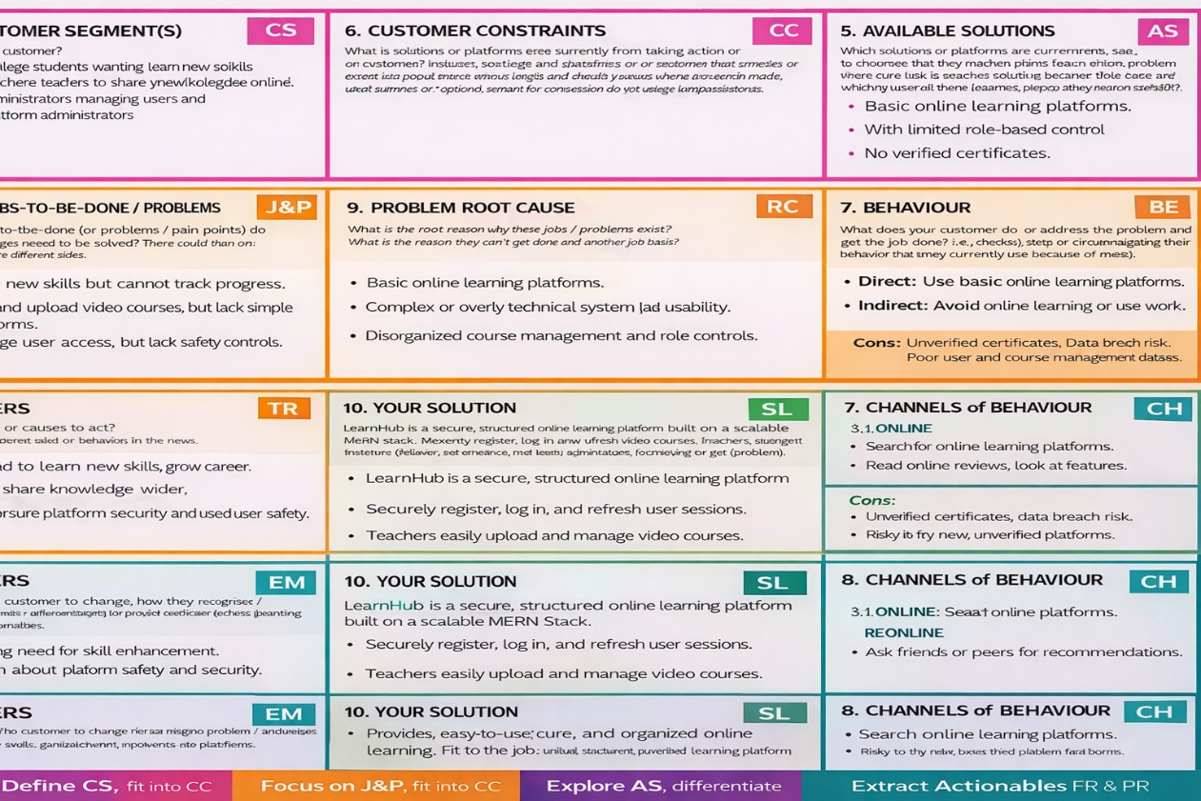

Problem–Solution Fit Template
1. CUSTOMER SEGMENT(S)
- Students seeking structured online learning
- Teachers who want to create and manage digital courses
- Administrators managing course approvals and system control
- Educational institutions looking for scalable LMS solutions
2. JOBS-TO-BE-DONE / PROBLEMS
- Access secure and structured online courses
- Track course progress effectively
- Receive certification after completion
- Manage video course content easily (for teachers)
- Prevent unauthorized access to paid courses
- Ensure role-based system control
3. TRIGGERS
- Growth of online learning demand
- Need for remote education solutions
- Increasing requirement for skill-based certification
- Institutions adopting digital learning systems
4. EMOTIONS: BEFORE / AFTER
Before: Confused, unorganized learning, lack of security, no proof of completion.
After: Confident, structured learning, secure access, motivated with certification.
5. AVAILABLE SOLUTIONS
- Basic video-sharing platforms
- Static course websites
- LMS without proper authentication or payment control
CONS:
- No structured progress tracking
- No secure enrollment system
- No automated certificate generation
6. CUSTOMER CONSTRAINTS
- Limited budget for premium LMS platforms
- Limited technical knowledge
- Concerns about payment security
- Resistance to adopting new systems
7. BEHAVIOUR
Direct:
- Register and log in
- Browse and enroll in courses
- Watch videos and complete lessons
Indirect:
- Share certificates on social platforms
- Recommend courses to peers
8. CHANNELS of BEHAVIOUR
8.1 ONLINE
- Web browser access
- Course dashboards
- Certificate downloads
- Online enrollment and payments
8.2 OFFLINE
- Word-of-mouth recommendations
- Institutional usage
9. PROBLEM ROOT CAUSE
Online learning platforms often lack integration between authentication, payment verification, structured course management, progress tracking, and certification. The root cause is the absence of a unified and secure full-stack system.

10. YOUR SOLUTION
LearnHub – A MERN-based Learning Management System that:
- Implements secure JWT authentication
- Provides role-based access control
- Supports structured video course management
- Verifies payment before enrollment
- Tracks section-wise progress
- Automatically generates certificates
- Ensures scalable and modular architecture

